Morgan Bronson

February 5th, 2022

Technical Report for Earthquake Map

Overall Map:

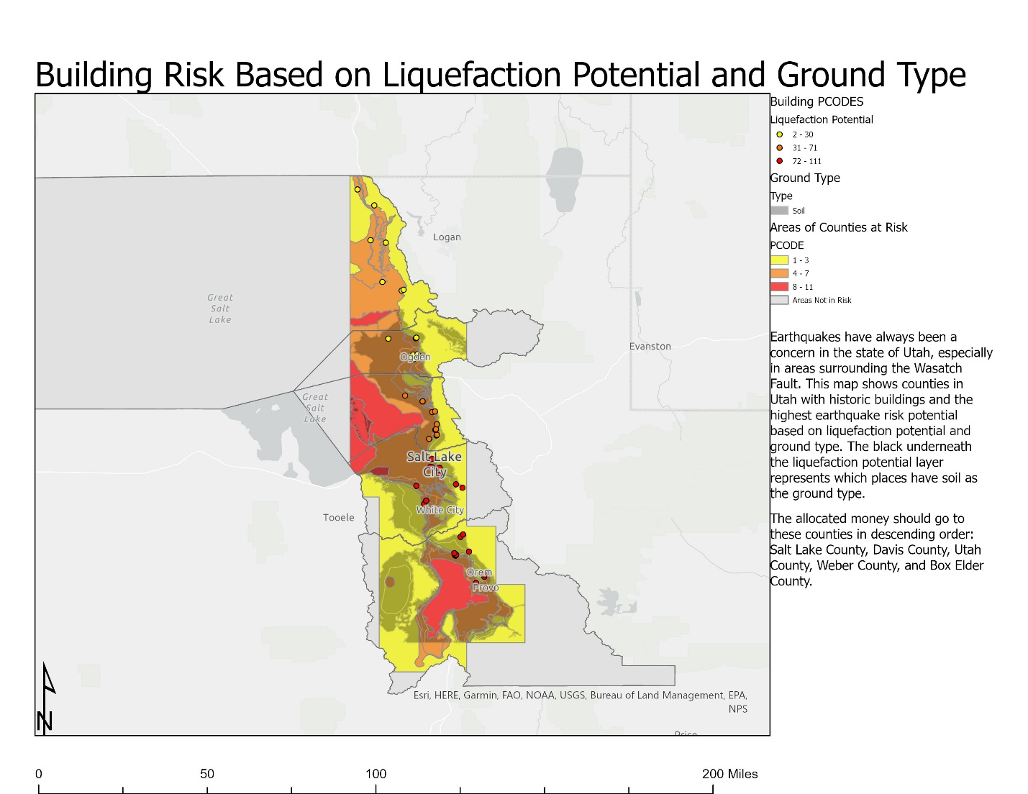

Methods:

* Mini Challenge 1: The green represents counties that have faults and the blue represents counties that don’t have faults.

|  |  |  |  |
| --- | --- | --- | --- |
| Process or Tool Used | Why I chose that tool | Parameters and Data | Results |
| Select By Location; Intersect | I wanted to find all of the areas where faults intersected with county lines, so I chose to use intersect to select all the counties with faults intersecting the boundaries. |  |  |

* Mini Challenge 2: The Utah Lake Faults have the longest distance in miles.

|  |  |  |  |
| --- | --- | --- | --- |
| Process or Tool Used | Why I chose that tool | Parameters and Data | Results |
| Calculate Geometry | I needed to calculate the length of the faults, and calculate geometry can do that with lines. |  |  |

* Mini Challenge 3: Millard County has the greatest total length of faults. The counties with the highest risk parameters are Utah County, Salt Lake County, and Davis County.

|  |  |  |  |
| --- | --- | --- | --- |
| Process or Tool Used | Why I chose that tool | Parameters and Data | Results |
| Select By Location; Summarize Within | Summarize Within allowed me to select all of the |  |  |
| Calculate Field | Calculate Field allowed me to take the summarized length in field and multiply it with population. I couldn’t have used Calculate Geometry because I wasn’t calculating a physical category of a polygon or line. |  |  |

* Mini Challenge 4: There are 56 buildings in the new feature class.

|  |  |  |  |
| --- | --- | --- | --- |
| Process or Tool Used | Why I chose that tool | Parameters and Data | Results |
| Merge | I had four different data sets that I wanted to combine into one dataset. I tried append, but that didn’t work, so I chose merge instead. |  |  |

* Mini Challenge 5: Drum Mountain Fault is approximately 137 miles. There are 63 young faults in Utah.

|  |  |  |  |
| --- | --- | --- | --- |
| Process or Tool Used | Why I chose that tool | Parameters and Data | Results |
| Dissolve | I chose dissolve because I needed to aggregate all of the faults that had the same name/feature. Dissolve allowed me to combine all the faults I needed to. |  |  |

* Mini Challenge 6: The reason that the Wasatch Fault segments didn’t dissolve together is because the attribute I used to dissolve the dataset was name, and those specific segments don’t share the same name.

|  |  |  |  |
| --- | --- | --- | --- |
| Process or Tool Used | Why I chose that tool | Parameters and Data | Results |
| Select | I couldn’t figure out how to sort each attribute out by their name, although I know that’s why they didn’t dissolve, so I went into the attribute table and selected all of the segments with the same name. |  |  |

* Mini Challenge 7: The buffers look like little marshmallows around the fault. I liked the dissolve tool better because it merged all of the edges of the buffers and made it look cleaner.

|  |  |  |  |
| --- | --- | --- | --- |
| Process or Tool Used | Why I chose that tool | Parameters and Data | Results |
| Buffer | I used Buffer because it allowed me to create a radius of an area a specified distance away from the selected object. |  |  |

* Mini Challenge 8: There are 737 schools within 5 miles of the Wasatch Fault.

|  |  |  |  |
| --- | --- | --- | --- |
| Process or Tool Used | Why I chose that tool | Parameters and Data | Results |
| Select By Location; Summarize Within | I used Summarize Within because I wanted to select all the schools that were within the buffer, and that tool allowed me to select all the schools within that range. |  |  |

* Mini Challenge 9: There are 764 schools in the state of Utah that are outside 5 miles of the Wasatch Fault.

|  |  |  |  |
| --- | --- | --- | --- |
| Process or Tool Used | Why I chose that tool | Parameters and Data | Results |
| Select By Location; Summarize Within (inverted) | Similar to above, I chose to use Summarize Within because I wanted all of the schools outside the buffer and the ‘invert relationship’ box allowed me to do that. |  |  |

* Mini Challenge 10: This map shows all of the schools that are within 5 miles of the Wasatch Fault and their liquefaction potential.

|  |  |  |  |
| --- | --- | --- | --- |
| Process or Tool Used | Why I chose that tool | Parameters and Data | Results |
| Intersect | I used intersect because I wanted all of the schools and the liquefaction potential of each school and the intersect tool allowed me to select both datasets and turn it into a new category. |  |  |

* Mini Challenge 11: Union: 286; Intersect 246. This map shows the overlap of the Wasatch Geology layer and the Liquefaction Potential layer.

|  |  |  |  |
| --- | --- | --- | --- |
| Process or Tool Used | Why I chose that tool | Parameters and Data | Results |
| Union | Union did not work very well because it selected all of the data from both polygons. |  |  |
| Intersect | I liked the Intersect tool more than the union one because only the areas that overlapped with each other were selected. |  |  |
|  |  |  |  |

* Mini Challenge 12: This map shows the areas of the Wasatch Geology layer that contain bedrock and soil. The green represents bedrock whereas the blue represents soil.

|  |  |  |  |
| --- | --- | --- | --- |
| Process or Tool Used | Why I chose that tool | Parameters and Data | Results |
| Dissolve | I used dissolve because the data was separated into different categories and I needed them aggregated into one category. |  |  |
|  |  |  |  |

* Mini Challenge 13:

|  |  |  |  |
| --- | --- | --- | --- |
| Process or Tool Used | Why I chose that tool | Parameters and Data | Results |
| Merge | I used the UT_Buildings layer that I created from all of the merged buildings so I could have all the buildings in those 5 counties. |  |  |
| Dissolve | I used the soil vs. rock layer that I made for Challenge 12. I wanted to use the soil layer to see which buildings are built on soil. |  |  |
| Intersect | I intersected the buildings and the liquefaction potential to get the PCODE of the buildings. I also intersected the liquefaction potential and the soil vs. rock layer to get all of the soil locations within the risk area. |  |  |

Conclusion: I think that these tools could be extremely useful in several different disciplines. The buffer tool could be used to find people outside 100 miles of a voting booth and could be encouraged to request a mail-in-ballot or the dissolve tool could be used to make a choropleth map of how each county voted in a presidential election. Tools like these make it easier for analysts and others to interpret data as well as present it in a way that other people can understand. As I worked on this assignment, I realized all of the other ways that these tools could be used for planning and zoning purposes, for collecting census data, and for determining which land is best for development. I even use some of these tools at work when I update Fremont County’s rivers. I think this application, along with all of the tools, are such good additions to several careers and data collection.